**PET APPOINTMENT AND VETERINARY RECORD SYSTEM FOR PETLANDIA IN MALOLOS CITY BULACAN**

A Project Proposal Presented to the

Faculty of Datamex College of Saint Adeline, Inc.

In Partial Fulfillment of the Requirement for the

Degree of Bachelor of Science in Information and Technology

# Members:

# Amponin, Alexis John

Ausa, Justin

Dueñas, Jhazen

Geronimo, Reymark

September 15, 2025

**PROJECT PROPOSAL**

# **INTRODUCTION**

Veterinary clinics help keep your pets healthy by giving them check-ups, treatments, and vaccines. Many pet owners rely on these clinics to care for their animals. However, managing appointments and keeping track of pet medical records can be hard when everything is written on paper. It takes time, can be messy, and papers can get lost or damaged. This can cause delays in treatment and confusion for Pet Owners and clinic staff.

To solve this, a digital system can be used to make things easier and faster. The Pet Appointment and Veterinary Record System is a stand-alone desktop application that helps pet owners and veterinary staff manage appointments and medical records more efficiently.

Today, many veterinary clinics still use manual or paper-based systems to schedule appointments and keep pet records. These old methods often lead to problems like lost files, missed appointments, and unclear health records. Also, pet owners may not always know their pets’ full medical history or when their next check-up should be.

The Pet Appointment and Veterinary Record System was made to fix these problems. It gives clinics a computer-based tool to keep all pet information in one safe place. Staff can easily check records, schedule visits, and make sure all pet details are correct. This system is important because it improves how clinics work and makes services better for pet owners. It helps save time, and keeps records safe.

**Objectives and goal of the project**

The main goal of this project is to design and develop a **Pet Appointment and Veterinary Record System** for Petlandia in Malolos City, Bulacan. The system aims to improve the efficiency of clinic operations by replacing the traditional paper-based process with a reliable, accurate, and easy to use digital solution.

1. Provide a digital system for scheduling and managing pet appointments.
2. Organize and secure veterinary records, including medical history, treatments, and vaccinations.
3. Give clinic staff and admin access to dashboards for monitoring appointments and records.
4. Reduce delays and errors in handling pet health information.
5. Improve client satisfaction by making services more efficient and accessible.

**CLIENT INFORMATION**

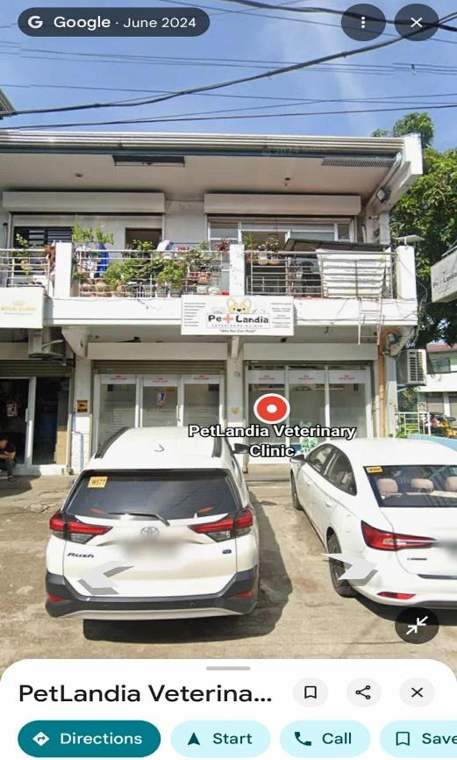

*Figure 1. Petlandia Vetenary Clinic*

The name of client was PetLandia Vets**,** currently landmark are in Sapphire Street, Capitol View Park Subdivision, Malolos, Philippines, if you have a concern contact them in this number 9044 8027334 or emailed them [petlandiavets@gmail.com](mailto:petlandiavets@gmail.com),

PetLandia Vets is a local veterinary clinic in Malolos Bulacan, they offered pet health check, blood parasite screening, vaccinations, treatment, grooming and etc. It serves dog and exotic pet owners in the community.

**PROJECT SCOPE**

This section defines the Inclusions and Exclusion of the Pet Appointment and Veterinary Record System. It outlines the system’s coverage, the features it will and will not include, the conditions assumed during its development. These details ensure that the project’s objectives and boundaries are clear to both developers and users.

**Inclusions**

**The Inclusion of the proposed system will be described as follows;**

* The system is a standalone desktop-based application designed for veterinary clinics.
* Admin Role - Can create, update, and delete appointments and veterinary records. Has access to a dashboard showing totals of appointments, registered owners, and pets.
* Staff Role - Can register owners and pets, book appointments, update veterinary records after a checkup.
* Appointment Management - Staff can schedule appointments with owner and pet details when the customer arrives.
* Veterinary Record Management - Records can be updated after consultations, including diagnosis and treatment details.
* Admin Dashboard - Displays statistical summaries for total appointments, owners, and pets registered.
* Staff Dashboard - Displays the list of book appointments.

**Exclusions**

**The Exclusions of the proposed system will be described as follows;**.

* The system works offline only (no cloud or remote access).
* No SMS, email, or online notification features for appointments.
* No mobile or web-based access — accessible only on the installed device.
* Limited to basic CRUD (Create, Read, Update, Delete) operations for records and appointments; advanced analytics or reporting features are not provided.
* Does not handle inventory or billing for veterinary services.

**The Assumptions the proposed system will be described as follows;**

* Users (admin and staff) have basic computer literacy and know how to operate the system.
* All appointment and veterinary record details are entered accurately by the staff.
* The clinic has an existing process for handling payments outside the system.

**The Constraints of the proposed system will be described as follows;**

* The system is dependent on the hardware where it is installed; performance may vary based on device specifications.
* Database capacity is limited to the storage space of the host computer.
* The system cannot synchronize or share data automatically across multiple computers.
* User access control is limited to predefined roles (admin and staff)

**PROJECT APPROACH**

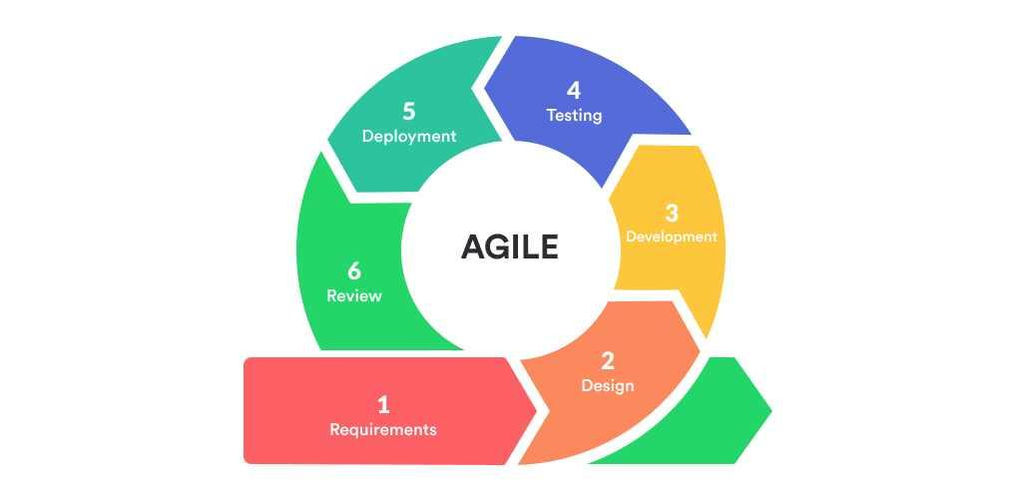

**AGILE MODEL**

To achieve the goals of the Pet Appointment and Veterinary Record System, the project will use an Agile methodology. Agile is a flexible and step-by-step approach that focuses on building the system in smaller parts (called iterations or sprints) and improving it based on feedback. This method allows developers to test and update the system regularly to ensure that it meets the needs of the veterinary clinic.

Requirements In this stage, we collect all the required information for the system. This ranges from knowing the key users (admin and staff), what they do, and what features they require, for instance, appointment scheduling, management of veterinary records. We also outline what the system will not have, for example, payment processing.

Design After the requirements are defined, we design the layout and structure of the system. This entails setting up the booking appointment interface, veterinary records management, and dashboard viewing. We aim to make it easy and straightforward for staff and admin to use.

Development This is where we begin to construct the system according to the designs. We work on each feature in small parts, beginning with the important functions, such as booking appointments and updating records. Each part results a functional version that can be analyzed and enhanced.

Testing Once we develop every component, we validate it to ensure that it functions properly and meets the specifications. whether appointments are saving correctly, and whether the dashboard is reporting accurate.

Deployment After the system has been put to the test and stabilized, we deploy it on the Veterinary clinic's computer for use. This entails installing the database, configuring the user accounts, and making everything run harmoniously in the real environment.

Review In this final phase, we gather feedback from the clinic staff and admin after using the system. Based on their input, we may improve certain features, fix small issues, or plan new updates for future versions.

This table will present the key activities and milestones, It will provide a deeper understanding on what phases and progress of the system, the estimated timeline that spent to create the system.

|  |  |  |
| --- | --- | --- |
| **Milestone** | **Description** | **Estimated Timeline** |
| Project Planning | Finalize goals, scope, and team responsibilities | Week 1 |
| Requirements Gathering | Interview users and list system features | Week 2 |
| System Design | Create flowcharts, dataset design, and UI mockups | Week 3-4 |
| Development | Code the system modules and integrate features | Week 5-8 |
| Testing & Debugging | Test all functions and fix bugs | Week 9 |
| Deployment | Install the system at the clinic and conduct training | Week 10 |
| Final Review | Evaluate feedback and finalize documentation | Week 11 |

*Table 1: Key Activities and Milestones*

*\*

**PROJECT TEAM**

The system was created through a team of skilled members who worked together to make it possible. Mr. John Alexis Amponin, the Programmer, built and implemented the system, while Mr. Reymark Geronimo and Mr. Justin Ausa, as Data Gatherers, collected and analyzed important information. Mr. Jhazen Dueñas, the Designer, made the system accessible.

|  |  |  |
| --- | --- | --- |
| **NAME** | **ROLE** | **SKILLS AND EXPERIENCE** |
| 545763611_2729781320703069_2017396145209028391_n Amponin, John Alexis | Programmer | Mr. Amponin is a Programmer that execute the expectations of stake holders and clients, his ability to be able to improve and implement the current problem that solve by using a system, establishing the development process of pet appointment and veterinary record management system. |
| 545959714_765949866058212_3367174395666903984_nGeronimo, Reymark | Data gatherer | Mr. Geronimo Data Gatherer, he has remarkable skills in terms of data gathering, his ability of analyzing information to analyzing information to support a system on how is it important to make a system about, pet appointment and veterinary record management his role was very important to make a good point of what system would do. |
| Au546500059_682778177485520_2953674886028851917_nsa, Justin | Data gatherer | Data Gatherer Mr. Ausa he also a data gatherer who responsible of taking care of information that gathered in different areas to make a reliable source of information his skills were relevant to the project because his rote would be reliable for making system worth to release for veterinary clinics innovations. |
| Dueñas, Jhazen  *543798774_2087202105143860_8724650104398704793_n* | Designer | Mr. Duenas is a designer who has ability to make a UI design fits in client and stakeholder’s tastes, his skills of designing would lead to customers satisfaction of the system, his skills are very important to make a good experience of clients in pet appointment. |

*Table 2. Project Team*

**PROJECT TIMELINE**

The development of the Pet Appointment and Veterinary Record System will follow a structured timeline divided into key phases. Each milestone builds upon the completion of the previous task, making some steps critical paths to overall project success.

This part was the high-level timeline and milestones, it is also important to know the milestones, activities, deliverables and dependency on how things work as a group to create a pet appointment and veterinary record management system.

|  |  |  |  |
| --- | --- | --- | --- |
| **Week** | **Milestone/Activity** | **Deliverable** | **Dependency** |
| Week 1 | Project planning & role assigned | Project plan, assigned team | None |
| Week 2 | Data gathering & requirement analysis | User needs and features list | Project planning |
| Week 3-4 | System design  (UI mockups, flowchart, database) | System architecture, wireframes | Requirements gathered |
| Week 5-8 | System development (coding phase) | Functional prototype of the application | Completed system design |
| Week 9 | Testing & debugging | Bug reports, errors fixes, and improve system stability | Working prototype |
| Week 10 | Development & training | Installed the system at the clinic, user guide | Tested system |
| Week 10 | Final review & documentation completion | Final documentation, user feedback, and project report | Development testing |

*Table 3. High-Level Timeline and Milestones.*

**PROJECT RESOUCES**

This section explain the necessary resources of technical and human to complete the development and deployment of the Pet Appointment and Veterinary Record System. It also includes a simple breakdown of the estimated budget.

**Human Resources**

The human resources are part of creating a system and brief overview, of what team members are capable of doing something, that relates for creating of pet appointment and veterinary record management system.

* Amponin (Programmer) - Develops the system using appropriate tools
* Dueñas (UI/UX Designer) - Design the user interface for ease of use.
* Ausa (Data Gatherer) - Conduct field research and collects system requirement
* Geronimo R. (Data Gatherer) - Prepares all project documents and reports

**Technical Resources**

By creating a system, the team needs a different flatform for creating a pet appointment and veterinary record management system, this tables will be able to give a presentation, on what are the platforms that used to create a system.

**Resource**s

* Laptop/ Intel core i5 /8gb ram / ryzen amd 5th gen 8gb ram
* Desktop PC

**Description /Purpose**

For system development and testing Microsoft Office for documentation and report writing Visual Studio Code , XAMPP /local database setup Paper Forms Used for collecting pet and owner details manually.

**BUDGET ALLOCATIONS**

This table will show the budget for the project. It will explain where the money will be used and why it is needed. It will also show how we will keep costs low by using free software tools and equipment provided by the team or the clinic.

|  |  |  |
| --- | --- | --- |
| **Item** | **Estimated Cost** | **Justification** |
| Printing of Forms & Docs | ₱ 500 | For owner info forms and project documentation |
| Flash Drive (Backup) | ₱ 300 | For storing backups of the system during development |
| Software Tools (if needed) | ₱ 0(Fee tools) | Open-source tools SQLite, Visual Studio Community Edition |
| Contingency Allowance | ₱ 200 | For unexpected small expenses |
| Estimated Total Budget | ₱ 1000 | The project relies on mostly free software tools to reduce costs. Hardware will be provide by team members or the clinic if needed for deployment. |

*Table 4. Budget Allocations*

**RISK MANAGEMENT**

This table presents the possible challenges that may affect the project, such as data loss, time constraints, and software bugs or errors. Each risk is described to show how it can impact the development process, and corresponding mitigation strategies are provided to reduce their effects. By identifying these risks early and preparing solutions, the project team can ensure smoother progress and increase the chances of successful implementation.

*Table 5. Risk management*

|  |  |  |
| --- | --- | --- |
| Risk | Description | Mitigation |
| Data Loss | Project files or pet record may be accidentally deleted or corrupted. | Regularly back up the system and documents using USB. |
| Time Constraints | Team members may have limited availability due to academic or personal schedules. | We set a clear timeline and assign tasks with deadlines. hold regular progress check-ins. |
| Software Bugs or Errors | Bugs during development may delay progress or affect system performance. | Conduct thorough testing in phases. Debug and fix issues before final deployment. |

**COMMUNICATION PLAN**

The team will use a combination of digital tools and face-to-face meetings to ensure consistent and clear communication. Project updates, task tracking, and documentation sharing will be done through accessible platforms to keep everyone aligned with the project’s progress.

The table will show the types of meetings for the project. It will explain how often they will happen, the format used, and their purpose. It will also help us to ensure good communication and smooth teamwork during the project.

|  |  |  |  |
| --- | --- | --- | --- |
| **Meeting Type** | **Frequency** | **Format** | **Purpose** |
| Team Planning Meetings | Once a week | In-person / Group Chat | Review progress, assign tasks, and discuss challenges |
| Quick Check-ins | As needed | Messenger / Chat | Clarify instructions or resolve urgent issues |
| Stakeholder Updates | Once every 2 weeks | Email / In-person | Update the clinic supervisor on system progress |
| Final Presentation | End of project | In-person | Demonstrate the system and collect feedback |

*Table 6. Frequency and Format of Project Meetings*

|  |  |  |
| --- | --- | --- |
| **Stakeholder** | **Role** | **Preferred Communication** |
| Project Team Members | Development and planning | Messenger, Google Drive, and In-person |
| Veterinary Clinic Staff | End users/system testers | Face-to-face, printed forms |
| Adviser / Instructor | Project reviewer | Scheduled meetings, email |

*Table 7. Key Stakeholders and communication Preference*

**PROJECT GOVERNANCE**

The project will be governed through a collaborative decision-making process, where each team member is responsible for their assigned role, but all major decisions are discussed as a group. Regular meetings will be held to review progress, resolve issues, and approve any changes to the project scope or timeline

**Roles and Responsibilities of Project Stakeholders**

* Geronimo, The Data Gatherer Documentation Specialist Handles all written reports, project proposal, and final documentation.
* Dueñas , The UI/UX Designer who designs user interface and ensures the system is user-friendly.
* Amponin, The Lead Programmer, Develops the system, codes the features, and handles bug fixes.
* Ausa, The Data Gatherer Lead Collects requirements, interviews clinic staff, and compiles user feedback.